HIGHLIGHTS

01 April 2021 to 30 Jun 2021
(For Private Circulation Only)
I EDITION
SAINIK SCHOOL BALACHADI
Jamnagar, Gujarat-361230

- Editorial Board
- Patron’s Message
- Academics
- Co-Curricular
- UPSC Corner
- NCC Corner
- Miscellaneous
- PTMs & Conferences
- Gallery

The balachadi mail

EDITORIAL BOARD

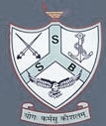
PATRON: GP CAPT RAVINDER SINGH, PRINCIPAL

CHIEF EDITOR : Lt Cdr Manu Arora, Vice Principal

EDITOR : Mr. Balraj, TGT English

STATISTICAL SUPPORT : Mr. Munish Kumar Singh, OS

CADET EDITORS : Cdt. Atharv Kumar (6271),
Cdt Abhishek Kumar (5807)
UPSC DATA SUPPORT : Dr Mahesh Bohra, HOD, Maths
PHOTOGRAPHY : Mr. R. S. Mishra, Art Master

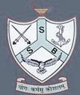
PATRON PENS
‘’The power we discover inside ourselves as we survive a life-threatening experience can be utilized equally well outside of crisis, too. I am, in every moment, capable of mustering the strength to survive again-or of tapping that strength in other good productive, healthy ways.’’
Michele Rosenthal
The first quarter (April-Jun 2021) of the Academic Session 2021-22 was full of online Teaching-Learning Process. It included interactions with Cadets, Parents, Staff and Officers in terms of Academics, Co-Curricular and safety against Covid-19 Pandemic and Covid Appropriate Behaviour. The session triumphed with safety, precautions, new hopes, aspirations, exploring netizen skills, accepting global pandemic as an opportunity to introspect latent potentials and shaping them to new visions and Result-Oriented accomplishments. It taught us not to react but to respond wisely. It proved that ‘’Sweet are the fruits of adversity.’’ Everything was worth gaining and cherishable. We touched greater heights extraordinarily rather than virtual Teaching-Learning methods. Keep inspiring and emerging in all situations. Always remember that every dark cloud has a silver lining. So once again with new hopes and blessings. We aim at better outcomes in future.

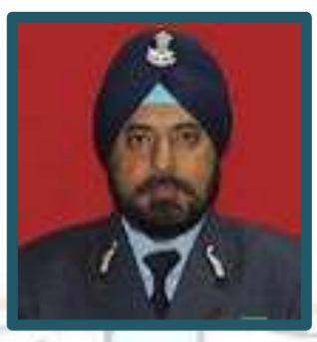
Gp Capt Ravinder Singh
PRINCIPAL

ACADEMICS

ACADEMIC CLASSES
Regular Academic Classes (Apr to Jun 2021) from class VII-XII have been at the utmost priority to keep the cadets continue with their Learning Outcomes. The Academic staff has been imparting knowledge in Regular Academic Classes, Assignments and Alternative Academic Activities were conducted Virtually.

PARIKSHA PE CHARCHA (VIRTUAL)
Academic Staff participated in Pariksha Pe Charcha (Vitual Mode) on 07 Apr 2021. The Pariksha Pe Charcha session focussed on making Fear free Learning Environment and Stress-free Conduction of Exams. PM Narendra Modi addressed and urged the teachers to give preference to conduct the exams through Virtual mode.

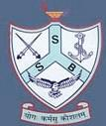
CO-CURRICULAR
HOBBY CLASSES IN SUMMER VACATION
School conducted Hobby Classes in Summer Vacation from 02 May 2021-15 Jun 2021 for the fruitful utilization of the summer vacation and enhancing important life skills among the cadets. Yoga, Dance, Music, Photography and Dining Etiquette classes were conducted by the Principal, Vice Principal and concerned Academic staff. It also paved a way to the school Administration to be in regular touch with the cadets. These classes were conducted on weekly basis from 1630-1730 Hrs.
YOUNG WARRIOR MOVEMENT AGAINST COVID-19
The Academic staff attended Young Warrior Movement Against Covid-19 on 11 Jun 2021 through Virtual mode. It was a global movement organized to create awareness against the COVID-19. It was attended through Virtual Mode on You Tube. It focused on ‘How teachers can roll it out in schools effectively’.
INTER HOUSE ENGLISH SPEECH COMPETITION
The cadets participated in the Inter House English Speech Competition organized on the occasion of International Yoga Day. The event was conducted through online mode on 20 Jun 2021. The topic of this Inter-House Speech Competition was History and Benefits of Yoga. The participants were very confident and well prepared. The participants displayed their excellent Oratory skills. It was conducted in two Categories i.e. Cat-I VII to VIII and Cat-II IX to XI respectively.
Gp Capt Ravinder Singh, Principal the Chief Guest of the event congratulated and expressed immense pleasure for the cadets’ active and zealous participation. On this occasion Lt Cdr Manu Arora, Vice Principal, Academic Staff and the cadets from classes VII-XII joined and witnessed the event virtually. Mrs Anju Yadav, TGT English I/C of the event, coordinated the event successfully.
UPSC CORNER
UPSC NDA/NA (PREPARATION, EXAM & RESULTS)
SSB Core team of the School has been keeping the NDA aspirants cadets on their toes by imparting quality education through Virtual mode. School uploaded E-content on school’s website for their better preparation and guidance. The cadets showed their optimum interest in the exam & preparation.
Chasing their dream destination 16 cadets of class XII cleared their UPSC NDA/NA Written Exam. The cadets, who cleared their UPSC Written Exam have been undergoing SSB Training these days conducted by the SSB Core Team of the school.
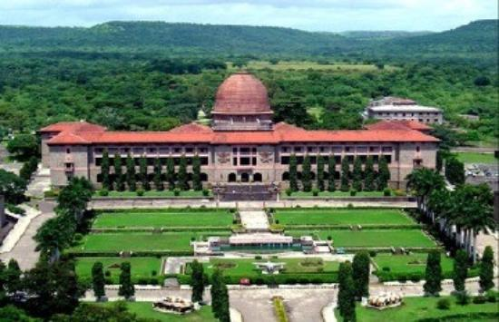

NCC CORNER

#EK MAI SAU KE LIYE CAMPAIGN BY NCC.
The Cadets from classes IX-XI participated in Ek Mai Sau Ke Liye awareness and assisting campaign initiated by NCC. In this campaign the cadets connected virtually and interacted with the Veterans, Friends and Ex Servicemen and asked their well being, status of Vaccination and requested them for the Covid Appropriate behavior. The cadets aslo recorded 2 minutes videos and sent to Guj NCC Dte. The Balachadians excelled well as usual and earned special complements by the ADG NCC Guj.

FAREWELL TO SUB RATAN SINGH RATHOD.
School bid farewell to out going Sub Ratan Singh Rathod on 18 Jun 2021. A high tea party was organized on this occasion maintaining proper Covid protocols. Gp Capt Ravinder Singh Principal Sainik School Balachadi wished Best of Luck in his future endeavours. On this occasion Lt Cdr Manu Arora, Vice Principal also read a Farewell note to the out going JCO Sub RATAN Singh Rathod.

YOUTH LED AWARENESS PROGRAMME AGAINST COVID-19
‘’I AM A # YOUNG WARRIOR’’ a Youth Led Awareness Programme against Covid-19 was organized by CBSE together with Ministry of Youth Affairs and Sports, Ministry of Health and Family Welfare and UNICEF. It aimed to promote the citizens for Covid Vaccination Registration, Social Distancing, Mask Up India, Covid Appropriate Behaviour and Rumour Busting etc. The Staff and the Cadets from classes VII-XI took part in the create awareness and motivate the citizens against Covid-19. ‘I Am A#Young Warrior’ (For UNICEF Certificate).

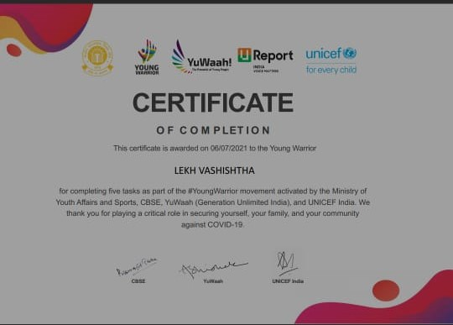

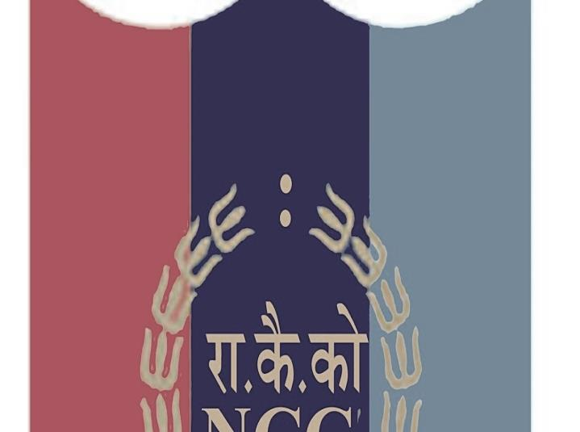
JOINING OF NEW JCO TO SS BALACHADI
Sub Pratap Singh joined Sainik School Balachadi on 18 Jun 2021.
Gp Capt Ravinder Singh, Principal Sainik School Balachadi introduced and welcomed him. On this occasion a high tea party was organized by the school. Gp Capt Ravinder Singh Principal wished him Best Wishes in his future endeavours.

NCC STAFF MEETING.
Lt Cdr Manu Arora OC NCC Coy Sainik School Balachadi conducted a staff meeting. He welcomed the new member of the NCC Coy Sub Pratap Singh to the NCC Coy Staff. The agenda was to Plan and Work effectively in all the coming endeavours and to prepare Long Rolls and Data Base of the cadets. He also insisted some proposed activities to be done in regular classes for the betterment of the cadets. On this occasion all SD and JD ANOs and CTs were also present there.

CADETS’ ACTIVITIES ON DIGITAL FORUM OF NCC
As per the directions by the HQ DG NCC the cadets shared their details of contribution made by them during Covid-19 and other similar activities. The cadets of school’s NCC Coy registered themselves on Digital Forum of NCC. The cadets added their activities, images and experiences in Audio-Video formats as a cadet of NCC on the Digital Portal of the NCC. NCC Digital Forum is a platform for the Cadets to share their contributions towards National Integration and Nation Building.

MISCELLANEOUS

REPORTING BY X & XI CLASS CADETS
The cadets of classes X and XI reported to school after Lockdown from 01-05 Apr 2021. The school deputed certain teams to receive them at the Reception Counter. School’s medical team also conducted their Antigen Test. The cadets who brought RT PCR Test Negative reports and with proper Covid-19 protocols were given entry. The cadets were accommodated in separate House under strict medical observations as per the SOP issued by the Sainik Schools Society and CMHO. School did adequate arrangements to continue their studies in online mode during quarantine period.
Gp Capt Ravinder Singh, Principal and Lt Cdr Manu Arora, Vice Principal briefed the cadets to stay healthy and follow the safety measures properly.
Later on due to outbreak in second wave of the Covid and as per the guidelines by the Sainik School Society the cadets were sent back to their hometowns.

TRAINING AND DEMONSTRATION TO USE TATA SMART CLASSEDGE EFFECTIVELY
Training and Demonstration session was conducted on 12 Apr 2021 to empower the Academic Staff to use the Tata Smart Classedge effectively. It also aimed to use the Tata Smart Classedge in online classes. All the Academic Staff attended the Training session and learnt about the Technical aspects of the Tata Smart Classedge’s functioning.

HEALTH AND WELLNESS SEMINAR BY CBSE
Academics Staff, Cadets and Parents attended Health and Wellness Seminar on 12 May 2021 through Virtual mode. It aimed at providing and developing Psycho-Socio support during the Pandemic.
https://youtu.be/Vo3IntzAD94
DISASTER RISK MANAGEMENT COURSES BY NCC STAFF.
NCC staff of the school registered for the Disaster Management Mini Courses by Gujarat Institute of Disaster Management. T/O Dr Bhavesh Chandegra and CT Ms Ankur Chaudhary attended the various courses from 02-10 Jun 2021. Disaster Management, Disaster Risk Governance, DRR Future Thinking, System Risk etc. were the various themes of the said courses.

WORLD ENVIRONMENT DAY
The cadets from classes VII to XI participated in the various activities on the occasion of World Environment Day on 05 Jun 2021. School organized it through Virtual mode. The cadets participated in various activities such as Poster Making, Quizzes and Speech Competition.
ONLINE QUIZ BY GPCB 2021
Gujarat Pollution Control Board Gandhinagar, Gujarat organized an online Quiz on 05 Jun 2021 on the occasion of World Environment Day. The theme was to create an awareness toward the declining status of the Environment. The cadets from classes VII to XI took part in it and were awarded Digital Certificates.
7Th INTERNATIONAL DAY OF YOGA AT SS BALACHADI.
Sainik School Balachadi observed 21 Jun 2021 as 7Th International Yoga Day. The Officers, Academic, Adm Staff, Day Scholars and the Families attended the Morning Yoga Session on this occasion. Mr Bhavesh Chandegra, HOD Gujarati conducted various Yoga asans. The theme of this year was BE WITH YOGA BE AT HOME. Adequate seating arrangements were done by the QM following the proper protocols of COVID. The attendees pledged to continue with the Yoga in their day to day life. On this occasion, the cadets participated in various activities related to International Yoga Day such as Poster Making, Drawing, Quizzes, Speeches, etc.

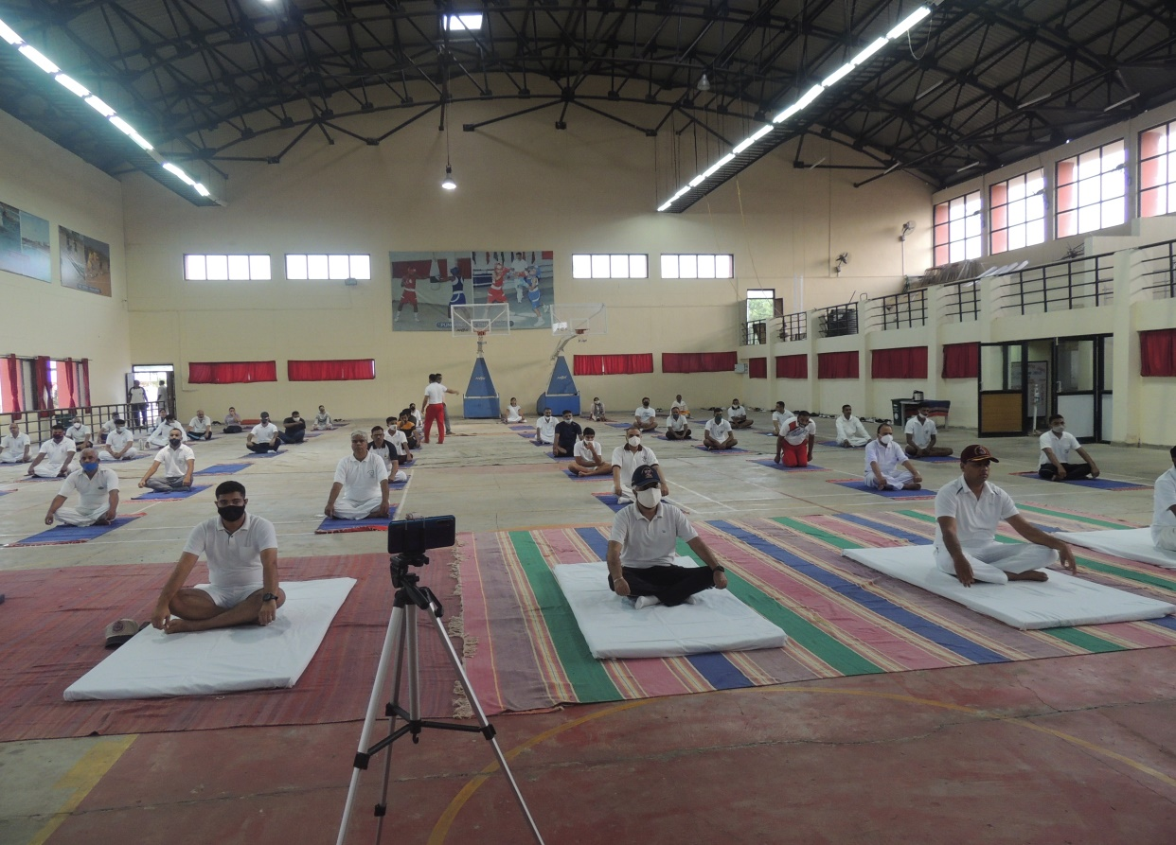

NEW-AGE EDUCATIONAL EMPOWERMENT TRAINING PROGRAMMES BY NDIM
As per the guidelines by the Ministry of Defence and Sainik Schools Society, Academic Staff attended various Online Training Programmes from 21 Jun 2021-02 Jul 2021 conducted by New Delhi Institute of Management. The Training Programmes are Capacity Building Programmes for Effective Teaching and Learning as per the existing scenario. This training aimed to train 9000 + Cadets and Teachers from the Sainik Schools all over India. It was a 12 days Virtual Training Programmes. The Training Programmes included the following topics.
Artificial Intelligence, Latest Teaching Aids/ Techniques
Use of Technology to conduct Online Exams
Organizational Behaviour with regards to Schools
Professional Ethics
Creating the Disciplined Environment in School
Developing Critical thinking Skills among the Students/Cadets
Developing Verbal and Written Communication Skills
Developing Effective Presentation & Facilitating Skills etc.

PTMs AND CONFERENCES

PTM FOR CLASS X
PTM for the cadets of class X was conducted on 16 APR 2021. The Class Coordinators conducted the PTM through Online Mode. The Principal also interacted with the cadets and their parents and addressed them to give utmost priority to Health and Studies. The parents assured their full support in this regard.
PRINCIPAL’S CONFERENCE WITH ACADEMIC STAFF
Gp Capt Ravinder Singh Principal conducted a conference with the Academic Staff on 23 Apr 2021. The Conference aimed on ensuring well being of the cadets, staff and families, attendance in Online classes, mental alertness of the cadets in classes, forming the WhatsApp groups of the parents to keep them updated.
The conference also aimed to organise various Hobby classes during the Summer Vacation to impart Learning and various other important Skills among the cadets. These include the following clubs.
Dance Club, Art Club, Philately Club, Literary Club, Online Blogging Club etc.
29-30 APR & 01 MAY 2021 PTM FOR CLASSES VII-XII
Class Coordinators conducted PTM for the cadets of classes VII-VIII on 29 Apr on 30 Apr for the cadets of classes IX-X and on 01 May 2021 for the cadets of classes XI-XII. The Class Coordinators informed the parents about the Summer Vacation and Summer Vacation HW. The class coordinators also urged the parents to take care of their wards and follow the safety measures to stay fit.
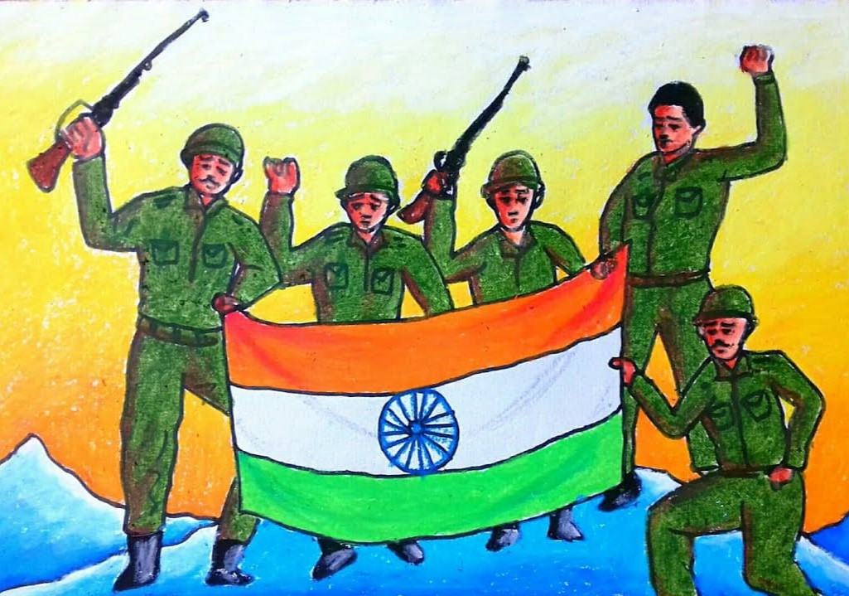
GALLERY

